**Debug for RT600**

We use jtag's swd interface to debug the program, here we need to link the application to ram.

1. We use the MCUXpresso IDE to debug the rt600. First, we need to link the application to ram, otherwise debug fails.

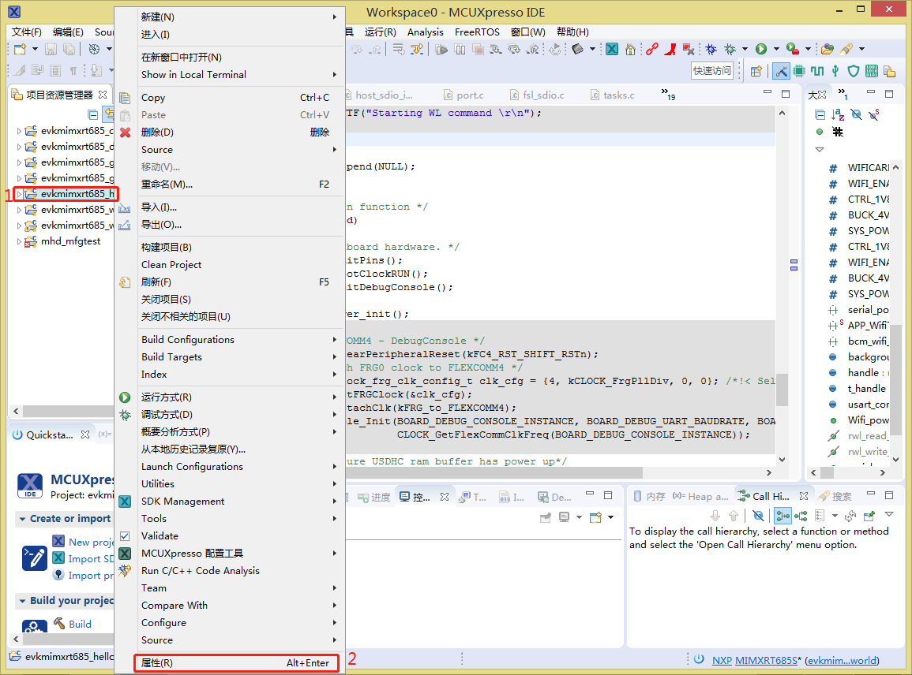

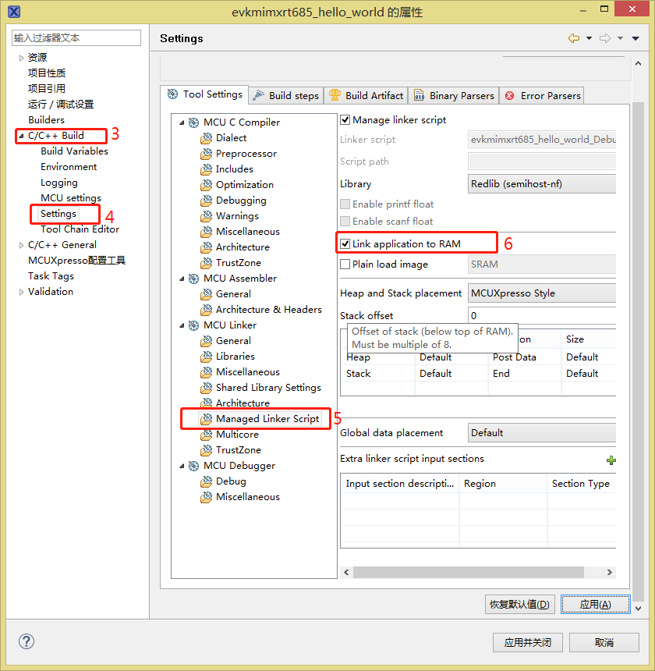



1. Connect jlink to mainboard

There are two ways.

 2.1 Use RT685 EVK board,  debug external DUT.

Remove EVK board JP18 and JP19 ,  JP18 pin2 connects  external DUT‘s SWCLK pin.  JP19 pin2 connects  external DUT‘s SWDIO pin. At the end, connect them GND together.

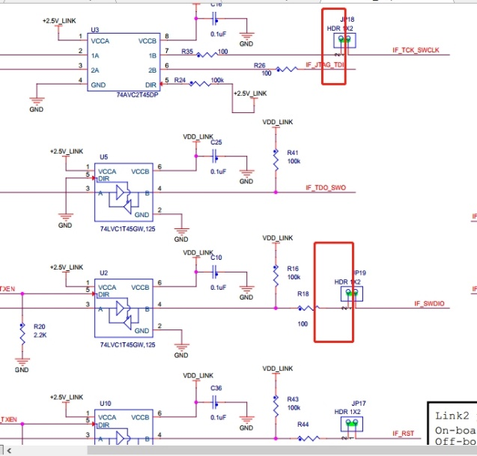 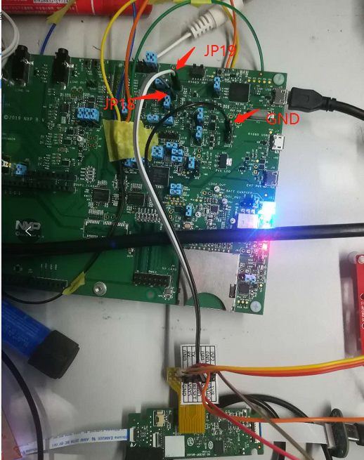

* 1. Use jlink, There may be a voltage difference problem.

**The J-link boxes must be licensed，Because our IO level of the main board is 1.8v, the IO level of the J-link box needs to be the same as that of the main board. Measure the PIN1 voltage of J-link before connecting the motherboard. If it is 3.3v, this J-link is not available. If it is no voltage or 1.8v, it can be used, At the same time, need connection SYS_1.8v for JLINK identification.**

JLINK need V9 and V10.

